ATSP CODING:

OPERATIONAL RISK ASSESSMENT AND MITIGATION FOR UAS OPERATION IN CONTROLLED AIRSPACE

This document defines the additional risk mitigation measures for UAS operations intended to be carried out in controlled airspace for a specific ConOps agreed in writing between the UAS operator and the Air Traffic Service Provider (ATSP) and establishes the coordination procedure to be followed to carry out the aerial activity. Likewise, when this is validated by ENAIRE, it constitutes evidence of the coordination of the aeronautical safety study, in compliance with Article 45.3.c of Royal Decree 1180/2018, and of the cooperation procedure with the ATSP, in accordance with point 2.4.1.c of AMC1 to Article 11 and, UAS.SPEC.040.040.1.b to Part B of the Annex to Commission Implementing Regulation (EU) 2019/947.
The aerial activity of the UAS operator shall comply with the provisions of this document. Any operation that does not fulfil the established conditions shall require further assessment and mitigation of operational risk and coordination with the ATSP, without prejudice to any sanctions that may be imposed for non-compliance with the agreed-upon measures.

UAS OPERATOR AND AIR TRAFFIC SERVICE PROVIDER'S DETAILS
Contact details for the purpose of strategic coordination and evaluation of this document between the two parties:
  - UAS operator's details
UAS operator's registration number | To be fulfilled by the UAS operator
Name or company name | Name or company name
Contact person | Name and surnames (position)
Telephone number | Tel.
Email | Email
  - Air traffic service provider's details
Name or company name | ENAIRE
Contact | ENAIRE Planea / drones.safety@enaire.es / web

Definition of the concept of operation (CONOPS) and scope of application
  - CONOPS
Operations shall be compliant with the following CONOPS:
OPEN CATEGORY, subcategories A1, A2, A3
VLOS
DAY-TIME and/or NIGHT-TIME
IN CONTROLLED AIRSPACE
WITHIN AND/OR OUTSIDE THE SAFETY DISTANCES TO AERODROMES
With UAS/RPAS of MTOM < 25 kg
MAXIMUM HEIGHT XX m, barring obstacles
This document is applicable to those aerial operations with unmanned aircraft that fulfil the following parameters:
- The UAS operator is registered.
- Operations will be conducted according to the open category, subcategories A1, A2, A3
UAS |  | Operation
C-Class | MTOM | Subcategory | Operational restrictions
Privately built | <250 g | A1 | - May overfly uninvolved persons (it should be avoided when possible)  - Overflying assemblies of people is not permitted
Legacy <250g
C0
C1 | <900 g |  | - No flight expected over uninvolved persons (if it happens, overflight should be minimised)  - No flight over assemblies of people
C2 | <4 kg | A2 | - Must not overfly uninvolved persons.  - Maintain a horizontal distance of 30 m from uninvolved persons (can be reduced to 5 m if the low-speed mode is activated)  - Maintain flight altitude below 120 m above ground level
C3 | <25 kg | A3 | - Must not overfly uninvolved persons  - Maintain a horizontal distance of 150 m from:  - Residential areas  - Commercial areas  - Industrial areas  - Recreational areas
C4
Privately build
Legacy >250g

- Height will be limited to a maximum of 120 m above ground. In the case of flights around an obstacle, it shall be possible to operate around the obstacle at a maximum horizontal distance of 50 m and to fly over the obstacle at a height of 15 m.
- The operations will take place in controlled airspace.
- They will be carried out within and/or outside the safety distances to aerodromes and heliports defined in the appendix to this document.
- UAS operations will not be autonomous.
- The operations will be conducted within visual line of sight (VLOS).
- They will be day-time and/or night-time operations.
- The operation will not be carried out from a moving vehicle // The operation may be carried out from a moving vehicle.
- The operation will not be conducted with the use of a line(untethered UA). // The operation may be conducted with the use of a line (tethered UA).
- The operation will not be carried out with FPV system. // The operation may be conducted with FPV system. For these operations, UA observers will be present to ensure VLOS.

  - Scope of application
This coordination is valid within the controlled airspace and aerodrome information area managed by the aerodrome ATS units:
Units where ENAIRE provides air traffic services
or
Type of airspace | Comments
Example: CTR Madrid

Complete table in case of specific EARO

UAS DESCRIPTION AND SEMANTIC MODEL
This section lists the UAS models to be used by the UAS operator and the description of the semantic model with the maximum flight geography, and the minimum contingency volume and air risk buffer that will be maintained.
  - Description of the UAS
The following table lists the UAS models to be used in the CONOPS operations described above:
 | UAS manufacturer and model* | Configuration | C-Class(if it applies) | MTOM (kg) | Dimension (m) | Speed (m/s) | Impact energy (Joules) | Autonomy (min)
UAS 1
UAS 2
UAS n

*The technical data of the UAS are provided by the different manufacturers in the aircraft documentation. A list of manufacturers and UAS with the most relevant technical data, including impact energy, is also available on the AESA website.
  - Semantic model
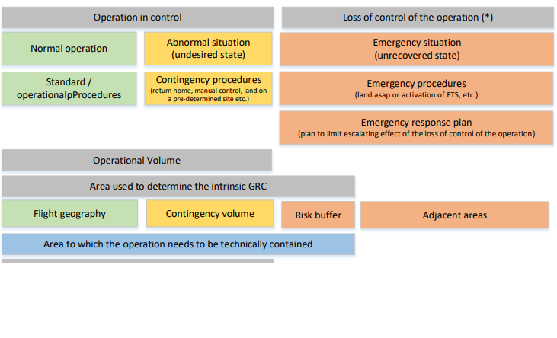
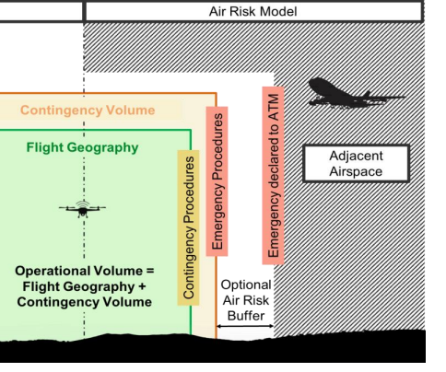
The semantic model is described according to the type of UAS indicated in the previous section. The data shown are maximum values for flight geography and minimum values for contingency volumes and safety buffers to be met by the operator in each flight. In calculating these distances, in addition to the type of UAS and its performance, weather constraints, flight profiles, contingency and emergency protocols, and remote pilot response times, etc., have been considered.

 | Maximum flight geography  (distances in metres) |  | Minimum contingency volume  (distances in metres) |  | Minimum air risk buffer  (distances in metres) |  | Comments  (**)
 | Horizontal* | Vertical | Horizontal | Vertical | Horizontal | Vertical
UAS 1
UAS 2
UAS n
(*) It represents the remote pilot – UAS distance, radius of the volume.
(**) The horizontal distance of the flight area will be reduced to 100 m in urban environments.

SPECIFIC MITIGATION MEASURES FOR CONTROLLED AIRSPACE OPERATIONS
UAS operations conducted in controlled airspace must meet the requirements established in Chapter XI of Royal Decree 1180/2018 and with the measures determined by the ATSP for this type of operation to guarantee the safety and continuity of UAS operations in the airspace.
COD. | TYPE OF MITIGATION | MITIGATION MEASURE | OBSERVATIONS
MAE01 | Strategic | Have the knowledge required to obtain a radio operator rating endorsed by a pilot licence or certification issued by an approved training organisation (ATO) or ultralight aircraft school. | Article 33.1.e RD 1036/2017
MAE02 | Strategic | Demonstrate an adequate knowledge of the language or languages used in communications between the controller and the aircraft, taking into account the operational conditions of the airspace in which the operation is conducted. | Article 33.1.e RD 1036/2017
MAE03 | Strategic | Have adequate communications equipment capable of sustaining two-way communications with aeronautical stations and on the frequencies indicated to meet the requirements applicable to the airspace in which it operates. | Article 46.1.a RD 1180/2018
MAT06 | Tactics | Have prior air traffic control clearance or communication to aerodrome flight information staff (AFIS). On first contact with air traffic service units, the callsigns of unmanned aircraft shall include the word "Unmanned". | Article 45.3.c RD 1180/2018
MAT09 | Tactics | Availability and implementation by the UAS operator of specific procedures for abnormal and emergency situations, with the main measure being radio/telephone notification to the ATS unit in the event of loss of control of the UAS (fly-away).
MAT08 | Tactics | Communicate the termination of the operation to the air traffic services (ATS) unit.
MAT20 | Tactics | Immediate landing by communication from the ATC service or traffic information from AFIS.

PROCEDURE FOR THE COORDINATION OF OPERATIONS WITH ATSP
The agreed-upon instructions to be followed to carry out each of the intended air operations by the UAS operator in controlled airspace are shown below:
ARCID callsign* | AEDRON#
Callsign* | AERODRON ##
Language to be used in aeronautical communications | SPANISH / ENGLISH
Primary means of communications | AERONAUTICAL RADIO / MOBILE PHONE
Alternative means of communications | AERONAUTICAL RADIO / MOBILE PHONE
NOTAM publication request | Outside the safety distances of the aerodrome | Within an urban environment: NO**
 |  | Outside an urban environment: As indicated by the ATS unit in flights above 60m
 | Within the safety distances of the aerodrome: As indicated by the ATS unit
*Notwithstanding that this may be modified during the tactical coordination or by the ATCO/AFISO during the operations based on its authority.
**Nevertheless, this may be required during the tactical coordination if considered convenient.
Procedure to be followed by the UAS operator to conduct any flight according to the coordinated CONOPS:
Flowchart of specific operations to this CONOPS prepared by the ATSP detailing the instructions, in chronological order, to be followed by the UAS operator to carry out a specific operation.
- If coordination with the aerodrome manager is required according to mitigation measure MAE09, the airport manager shall be contacted at least 20 business days before the operation.
- Minimum of 10 business days before the operation submit to the ATSP:
  - Copy of evidence of EARO coordination (this document) signed by both parties.
  - Operation-specific data
    - Specific place.
    - Date and time.
- The day before the operation (recommended) or up to 60 minutes before the start time of the operation, submit a flight plan for air traffic services (FPL) according to the ENAIRE guide available on its website.
(https://www.enaire.es/servicios/drones/lo_necesario_para_volar_tu_dron/volar_espacio_aereo_controlado_enaire)
- Before the flight:
  - Check that the ATS flight plan has been correctly submitted.
  - Pre-flight Information Bulletin (PIB) and/or NOTAM and weather in the area of operations.
- 30 minutes before the start of operations: contact the ATC/AFIS to confirm the operation.
  - In the first communication, the pilot shall report the reference number of the aerial work concerned (REF. ENAIRE XXX / Callsign XXX), including the word “UNMANNED” in the communication.
- Before the start of the flight: contact the ATCO/AFISO to obtain flight authorisation (take-off) or report it.
- After completing the operations:
  - contact the ATCO/AFISO and report the termination of the operations.
  - notify the closure of the ATS flight plan by calling the corresponding ARO office.
  - Notify the COOP of the termination and/or cancellation of operations.

abnormal and emergency situations specific procedures
The UAS operator shall adopt the following procedures for abnormal and emergency situations:

EVENT | PROCEDURE
Loss of communication with the ATSP (radio failure) | - If the communication failure is detected by the ATS unit:  - Establish communication by alternative means (landline or mobile phone) informing of the radio communication failure. Assess the continuity or cancellation of the UAS operations.  - If the communication failure is detected by the UAS operator:  - Maintain situational awareness by monitoring the airspace and "seeing and avoiding".  - Establish communication by alternative means (landline or mobile phone) informing of the radio communication failure and proceeding according to the ATS's instructions.  - If the operator is unable to establish communication by any means, he/she shall immediately terminate the flight by landing the aircraft in a safe place.  - Communicate the termination of the activity to the ATS unit as soon as possible by the relevant alternative means and cancelling the ATS flight plan.  - In the event of re-establishment of communications, the UAS operator shall newly obtain ATC clearance or AFIS communication to commence a new flight.
Loss of control of the UAS (fly-away) | If control cannot be regained and/or the position of the UAS is unknown:  - Consider activating the safe flight termination system according to the operator's procedures.  - Notify the ATS of the loss of control and position of the UA by radio/telephone as soon as possible:  - Callsign + "unmanned"  - Emergency due to loss of control of the unmanned aircraft  - Last known position, speed, course and height/altitude  - Remaining autonomy  - Report the termination of the emergency to the ATS when it is known that the UA is no longer in flight or it is certain that no further flight is possible (the maximum total UA autonomy time has elapsed)
 | OTHER

The contact addresses for notifications in case of abnormal or emergency situations are shown below:
Position | Contact
ATS Unit (civil/military) | Frequency / TLF // According to the unit affected. Provided during prior coordination
ENAIRE Airspace Operational Coordination Department (COOP) | ENAIRE PLANEA / cop@enaire.es
Airport Management Centre (AMC) / Airport Operations / Military Base | Depending on the affected unit. The Contact is provided during prior coordination.
Emergencies | 112

COORDINATION evidence AND VALIDITY
This coordination is valid indefinitely, subject, in any case, to the proper implementation of the mitigation measures and compliance with the established limitations or conditions of the operation and as long as compliance is maintained. Any modification or deviation from the contents of this document will require a new agreement. Where justified reasons exist, ATSP reserves the right to modify these terms and conditions or to revoke the agreement.
As proof of conformity and evidence of coordination, both parties’ consent to the present document:
The UAS operator | The air traffic service provider
In XXX, on 09 April 2024 | In Madrid, on ___ ___________ 2024_
Signed | Signature/seal
Position | ENAIRE Safety Technical
NAME AND SURNAMES

APPENDIX I. SAFETY DISTANCES WITH RESPECT TO AERODROMES
This risk assessment and coordination of operations shall be valid whenever the flight geography and its associated contingency volume according to the semantic model described above fall within and/or outside the aerodrome safety distances defined below:

a) At public and military airfields other than heliports:
1) Up to 45 metres in height measured from the Aerodrome Reference Point, hereinafter ARP: an area of 6 kilometres in length measured from the ends of the runway in the direction of the outward extension of the runway centreline and a width of 5 kilometres on both sides measured from the runway centreline. In all cases, the lower limit of this volume shall be the surface level.
2) More than 45 metres in height and up to 900 metres in height, both measured from the ARP: an area of 10 kilometres in length measured from the ends of the runway in the direction of the outward extension of the runway centreline and a width of 7.5 kilometres on both sides measured from the runway centreline.
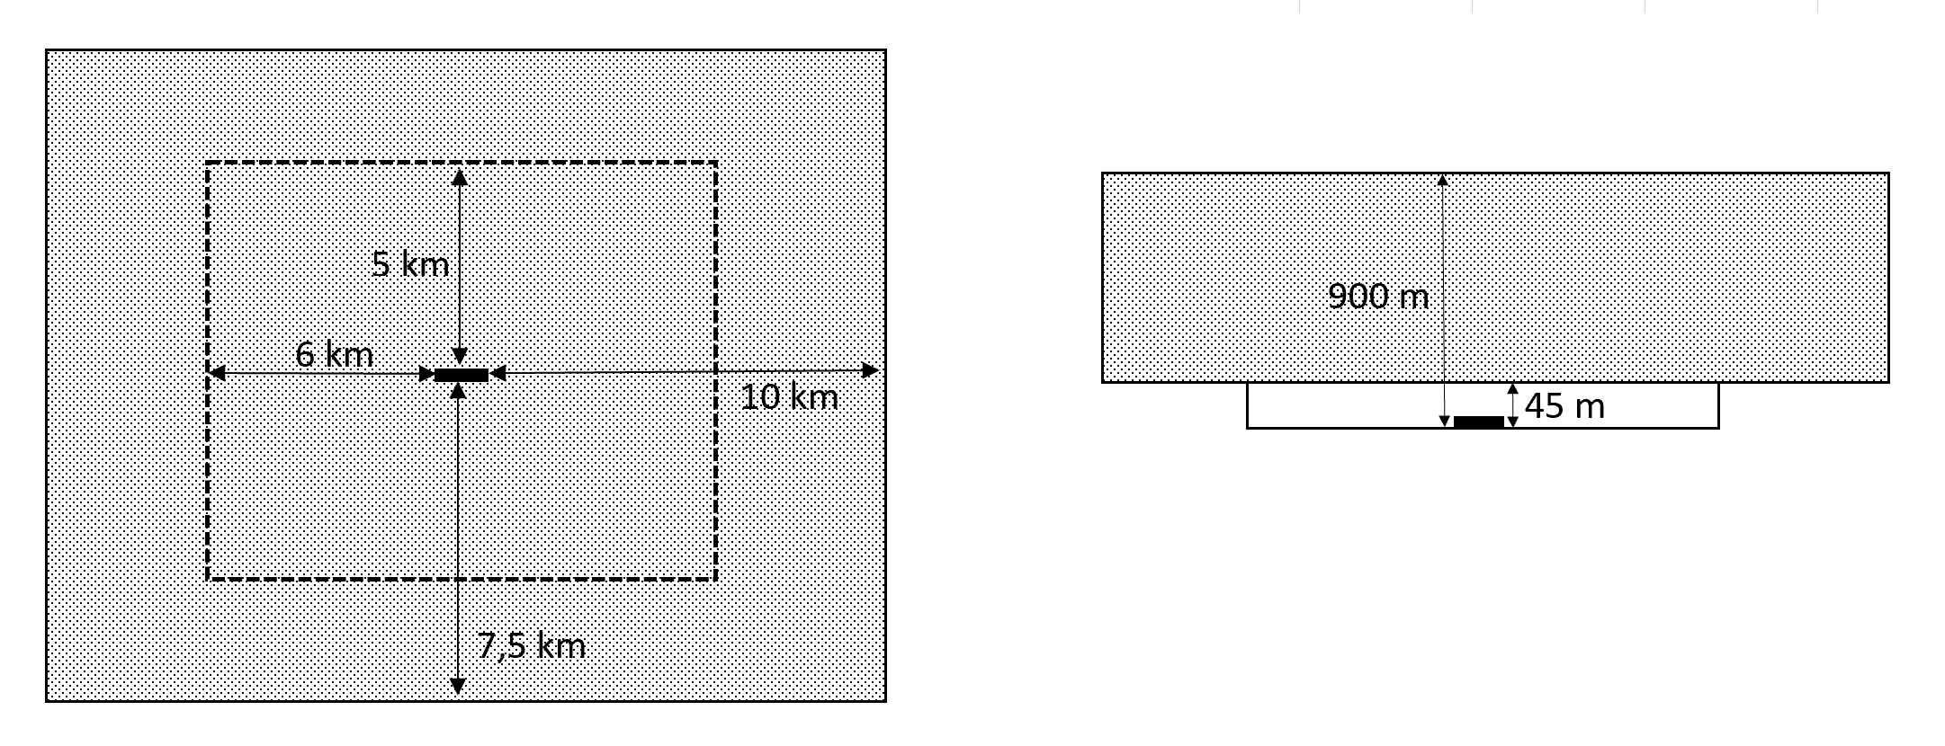

b) At public and military heliports:
1) Up to 90 metres in height measured from the Heliport Reference Point (hereinafter, "HRP"): an area of 2.5 kilometres in length measured from the ends of the Final Approach and Take-Off Area (FATO) in the direction of the outward extension of the FATO centreline and a width of 2.5 kilometres on both sides measured from the FATO centreline. In all cases, the lower limit of this volume shall be the surface level.
2) More than 90 metres in height and up to 900 metres in height, both measured from the HRP: an area of 3.3 kilometres in length measured from the FATO in the direction of the outward extension of the runway centreline and a width of 3.3 kilometres on both sides measured from the FATO centreline.
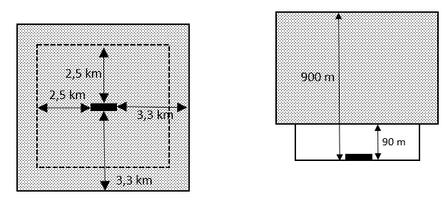

a) At restricted aerodromes other than heliports:
1) Up to 45 metres in height measured from the ARP: an area of 3 kilometres in length measured from the ends of the runway in the direction of the outward extension of the runway centreline and a width of 3 kilometres on both sides measured from the runway centreline. In all cases, the lower limit of this volume shall be the surface level.
2) More than 45 metres in height and up to 900 metres in height, both measured from the ARP: an area of 5 kilometres in length measured from the ends of the runway in the direction of the outward extension of the runway centreline and a width of 4.5 kilometres on both sides measured from the runway centreline.
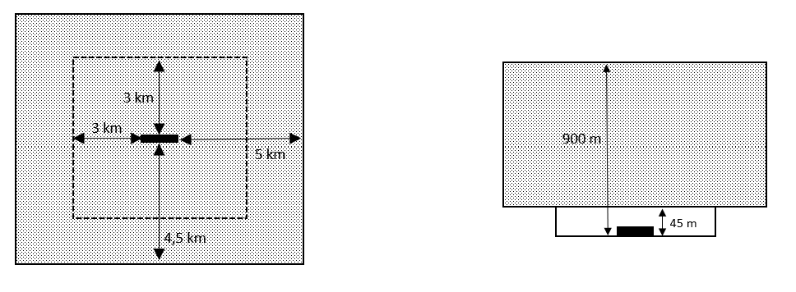

d) At restricted heliports:
1) Up to 90 metres in height measured from the HRP: a circular area with a radius of 2.5 kilometres from the centre of the FATO. In the case of restricted heliports with runway type FATOs longer than 100 metres in length, the above distance shall be considered as measured from each end of the FATO. In all cases, the lower limit of this volume shall be the surface level.
2) More than 90 metres in height and up to 450 metres in height, both measured from the HRP: a circular area with a radius of 3.3 kilometres from the centre of the FATO. In the case of restricted heliports with runway type FATOs longer than 100 metres in length, the above distance shall be considered as measured from each end of the FATO.
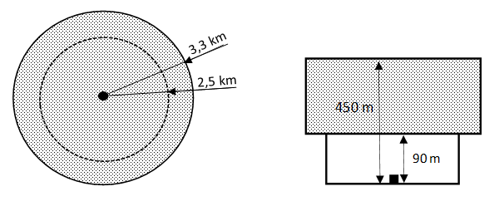

IMPORTANT: Pursuant to Article 45.3.b of Royal Decree 1180/2018, if the operation is at a minimum distance of 8 km from the reference point of any airport or aerodrome and the same distance from the runway centrelines and their extension, at both runway headings, up to a distance of 6 km from the runway threshold in an outward direction from the runway or, in the case of operations beyond the visual line of sight (BVLOS) of the pilot, when the infrastructure has instrumental flight procedures, at a distance of less than 15 km from said reference point, the operation shall be coordinated with the aerodrome manager.

APPENDIX II. PROOF OF COMPLIANCE WITH MITIGATION MEASURES
This appendix shows the implementation of the following mitigation measures:
- XXXX
- XXXX
- XXXX

APPENDIX III. ACRONYMS
AESA | State Aviation Safety Agency
AIP | Aeronautical Information Publication
ANSP | Air Navigation Services Provider
ATSP | Air Traffic Services Provider
ATS | Air Traffic Services
ATC | Air Traffic Control
ATZ | Air Traffic Zone
AFIS | Aerodrome Flight Information Services
ATCO | Air Traffic Control Officer
AFISO | Aerodrome Flight Information Services Officer
BVLOS | Beyond Visual Line of Sight
COP | ENAIRE Airspace Operational Coordination Department
CTA | Control Traffic Area
CTR | Controlled Traffic Region
EMA | Spanish Air Force
FPL | Flight Plan
MTOM | Maximum Take-Off Mass
NOTAM | Notice containing essential information relating to the establishment, condition or modification of any aeronautical facility, service, procedure or hazard that must be known in a timely manner by personnel conducting flight operations (NOTICE to AirMen)
PIB | Pre-flight Information Bulletins
STS | Standard Scenario
TRA | Temporary Reserved Area
TSA | Temporary Segregated Area
UA | Unmanned Aircraft
UAS | Unmanned Aircraft System
VLOS | Visual Line of Sight
PFRA | Photographic Flight Restricted Areas

Safety distances from aerodromes for the purpose of risk assessment and coordination of UAS operations in controlled airspace. These distances, based on the obstacle limitation surfaces around aerodromes, are detailed in the appendix to this document and are independent of the requirement for coordination of operations with the infrastructure manager required in Article 45.3.b of Royal Decree 1180/2018.
UAS as defined in Art. 20 of SR (EU) 2019/947, i.e. that have been placed on the market before January 1, 2024 and are neither privately built nor have class marking, shall be considered as "legacy drones".
UAS as defined in Art. 20 of SR (EU) 2019/947, i.e., that have been placed on the market before January 1, 2024, and are neither privately built nor have class marking, shall be considered as "legacy drones".

